NAME: ABINASH G UID EX 5 ROLL.NO:240701007

Task Analysis
Task Analysis is the process of breaking down a user's interactions with a system into smaller, manageable steps to understand how users achieve their goals. It helps in identifying user needs, pain points, and areas for
improvement.

Key Aspects of Task Analysis:
- Understanding what tasks users perform.
- Identifying the sequence of actions required to complete a task. •
Analyzing user pain points and inefficiencies.
- Defining requirements to improve the user experience.

User Flow
User Flow is a visual representation of how users navigate through an application to complete a specific goal. It shows the steps users take from the entry point to the final action.

Key Aspects of User Flow:
- Represents decision-making paths (e.g., what happens if a user cancels a form?).
- Maps different navigation possibilities (e.g., alternative ways to reach the goal).
- Shows how users move between screens.

User Flow for Electronics Buying App
Start → Open App → Browse/Search Electronics → View Product Details → Add to Cart
→ Checkout → Payment Authorization →

If Payment Successful:
Order Confirmed → Receive Order → Check Item → No Issue → Leave Review (Optional) → End

If Payment Failed:
Payment Failed → Update Payment → Checkout → Payment Authorization

If Item Has Issue:
Issue with Item → Contact Support → Return/Replacement Created → Return Label Provided → Item Returned → Refund/Replacement → End
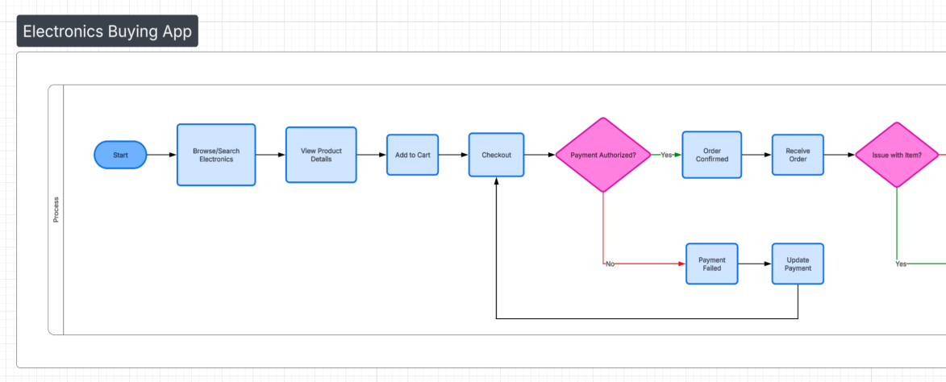
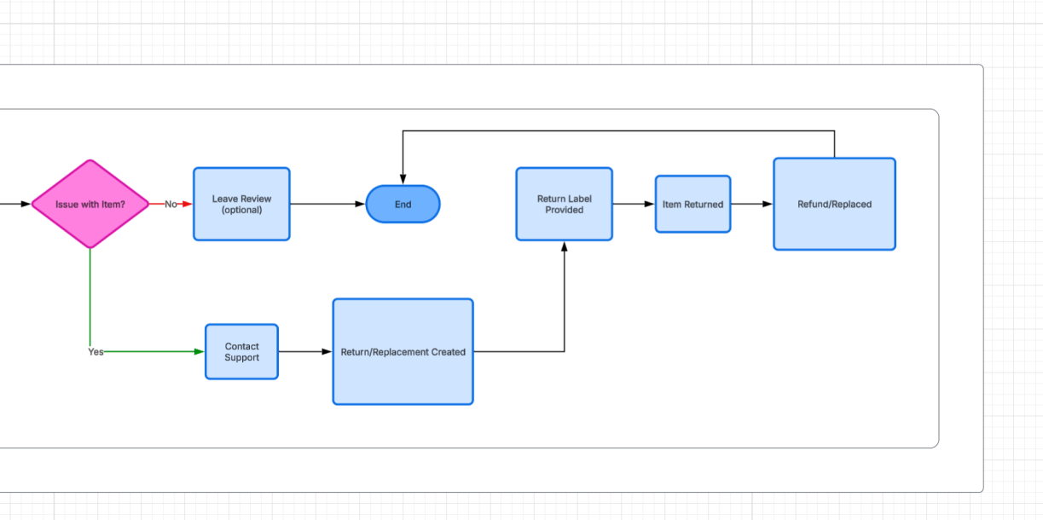

Steps in the Task Flow Step 1: Start
User opens the electronics buying application.

Step 2: Browse/Search Electronics
User searches or browses available electronic products.

Step 3: View Product Details
User checks product specifications, price, and reviews.

Step 4: Add to Cart
User selects the product and adds it to the shopping cart.

Step 5: Checkout
User proceeds to checkout to finalize the purchase.

Step 6: Payment Authorization
System verifies the payment.

If Payment Successful
  - Order is confirmed.

If Payment Failed
  - User updates payment information and retries.
Step 7: Order Confirmation System confirms the order. Step 8: Receive Order
User receives the product delivery.

Step 9: Check for Issues
User checks if the product has any issue.

If No Issue
  - User may leave a review.
  - Process ends.

If Issue Exists
  - User contacts support.

Step 10: Return/Replacement Process
Support creates return or replacement request.

Step 11: Return Label Provided
System provides a return shipping label.

Step 12: Item Returned
User sends the product back.

Step 13: Refund or Replacement

System processes refund or replacement.

Step 14: End
The process is completed.

